6. Writing SQL queries to filter and sort data from single table.
Create Table:-
use dbmt13;
show databases;
create table employees1(
id int primary key,
name varchar(100),
department varchar(50),
age int,
salary decimal(10,2)
);
select*from employees1;
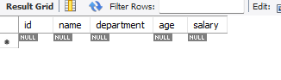
Insert some sample data:-
insert into employees1(id,name,department,age,salary)values
('1','riya','HR','28','40000'),
('2','shehal','IT','32','30000'),
('3','priya','IT','30','480000'),
('4','siya','Finance','27','280000');
select*from employees1;
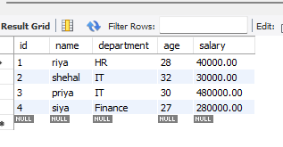

Filter Record Using Where:-
select*from employees1
where department='IT';
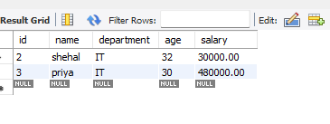
Sort Records Using Order By:-
select*from employees1
order by salary DESC;
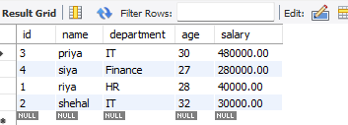
Combine Filtering and Sorting:-
select*from employees1
where age>25
order by age ASC;
